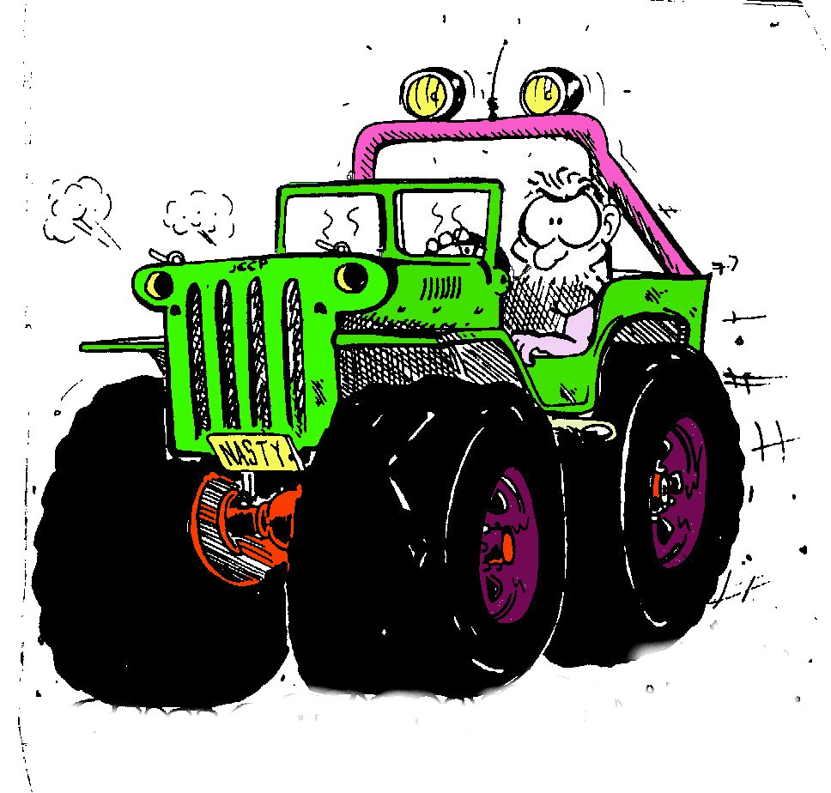
Invitation

Name of race TMK Nordic Off Road Trial
Value of race National Nordic Cup Original, Standard, Modified, ProModified ja
Prototype
Society/Membership amateur Standard
Location Raisio MotorSport Area
Date Saturday 15th September2012 11.00
Race licence number 2/OR/12
Catecories Original, Standard, Modified,Pro-Modified and Prototype
AmateurStandard
Rules Rules of Eurotrial 2012
Also rules named in this invitation and possible other rules that racecommitee may give
during competition.
In Amateur Standard class will be rules according AKK rulebook 2012

Inquiries Jarno Puumalainen +358400 535 302 GB / S/ FI
Reima Kirsiaho +358405442500

Arranger Turun Moottorikerho ry

Race Committee Manager Susanna Rantasalo RaisUa
Secretary Outi Saaristo
Head of judger Mika Listala
Judge Ari Kuutvuori Luumäen UA
Judge Erkki Keskinen MRT
Head of inspectors Teemu Levo MRT
Head of security Kari Takalo MRT
Head of sectionjudges Markku Viitala RaisUa

Announcements By email: reimakirsiaho(at)msn.com or
By mail:
Reima Kirsiaho
Leinikkikatu 4 B 10
20740 Turku Finland
At the latest 09.09 2012 09.00
We will accept max 70 vehicles in order of Announcements prefering Nordic Cup
catecory.
Arrager of this race withholds possibility to Chance the number of accepted vehicles
Track 6 section will be driven two times
Special Order Arranger of this race withholds possibility to cancel or chance the date of competition
when circumstancec demands.
Also arranger of this race withholds possibility to give addotional orders.
In this race will keep a rule of totaltime, there will be no separate correction time.
Arranger of this race may chance the closing time during the race.
If there will be sections not driven, those will Consider as non-driven sections (=500
penaltypoints)
In this race, there will be no official finishing line,that's why penaltypoints will decide
competitors placemens

Depot In depot there must be liquidproof mats onder racecars and cervicecars

Team One can announce just driver or driver and co-driver
One can announce just in one class

Drivers Licence In all classes both driver and co-driver must have valid AKK competitionlicence
as annuallicence or alternatively one may buy a introductory licence before race.
At the meeting 14th August 2012, AKK has decided that one can buy a introductory
licence to all classes
Groups Original. Standard, Modified, Pro Modified ja Prototype
In Standard class may be drivers also from JuniorClass

AmateurStandard drives same tracks as Standard Class
Modified and proModified will drive same tracks

Inspection certificate Car must have AKK admittedt inspection sertificate.
One can order inspection sertificate from AKK or alternatively it can buy from organizer.

Head of inspectors gives temporary inspection sertifite and AKK will send official sertificate
to the address you prefer.

Penaltypoints In this competition we observe Eurotril 2012 rules
groups Standard, Amateur Standard and Modified reversepoints will be tsecked during inspection car by car

ORGANIZER OF THIS RACE WILL NOT RECOMMEND RACING CAR WITH AIR BAG WICH ARE ACTIVE.
ORGANIZER OF THIS RACE WILL NOT ANSWER FOR ANY DAMAGE CAUCED AIR BAGS
EACH COMPETITOR HAVE AN OBLICATON TO ENSURE THAT CARS FLUIDS DO NOT FLOW IN THE GROUND

Payments All groups 60e/ team
Arrancer of this race will charce +40e if announcement arrives after 09.09.2012 09.00

Countnumber: Turun Moottorikerho ry
FI 28 4309 1520 0008 84

Racematerial Racingmaterial is available from raceoffice during announcement

Location Raisio MotorSport Area, approx. 2Km from Raisio to Rauma, sign Kustavi. Fron traffic
circle to Palovuorentie

Koordinate 60 30`59``N 22 8`57``E

Prizes 3 best teams shall have trophy´s

TIMETABLE
Saturday 15th of September 2012 07.30 raceoffice will be open 08.00 inspection begins 09.30 annoucement closes 09.45 racecommitee´s meeting 10.00 inspection ends 10.10 becomming familiar with tracks; this is compulsory and begins
from section number 1. Team meeting
11.00 Race begins 18.00 Race ends

This timetable is not binding and arranger of this race withholds the possibility to chance this timetable

Results will be announced as soon as they are accepted

Have a safe jorney and thank You for visiting us!

Announcement
TMK NORDIC OFF ROAD TRIAL

15.09 2012 Raisio

Driver Team Licencenumber

Co-driver Team Licencenumber

E-mail:

Car model and name

inspection sertificate number

Group
Original
Standard
Amateur standard
Modified
Promodified
Prototype
With our signature we confirm that we have read racerules, we are
committed to observe those rules and we will race at our own risk
Place Time

Signatures

Driver Co-Driver

Participation fee latest for this account

Turun Moottorikerho ,account number ,Fi 28 4309 1520 0008 84

09.09 2012 klo 09.00 mennessä

Advance announcenents 60€

Announcements after 09.09.2012 09.00 60€+40€

